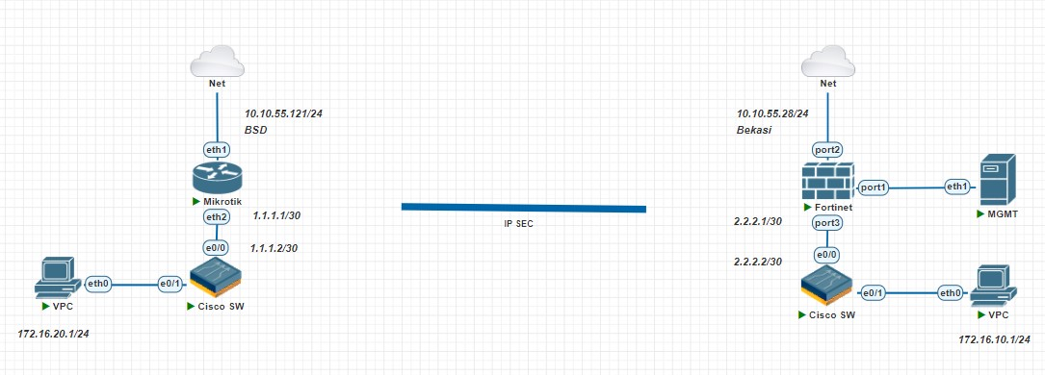

Konfigurasi site BSD

- Mikrotik

/ip ipsec profile
set [ find default=yes ] dpd-interval=5s nat-traversal=no
add dh-group=modp1024 dpd-interval=5s enc-algorithm=des name=profile1 \
nat-traversal=no
/ip ipsec peer
add address=10.10.55.28/32 name=peer-tunnel-to-forti profile=profile1
/ip ipsec proposal
add enc-algorithms=des name=proposal1 pfs-group=none
/ip ipsec identity
add peer=peer-tunnel-to-forti
/ip ipsec policy
add dst-address=172.16.10.0/24 peer=peer-tunnel-to-forti proposal=proposal1 \
src-address=172.16.20.0/24 tunnel=yes

/ip route
add disabled=no dst-address=172.16.20.0/24 gateway=1.1.1.2 routing-table=main \
suppress-hw-offload=no
add disabled=no dst-address=0.0.0.0/0 gateway=10.10.55.254 routing-table=main \
suppress-hw-offload=no

/ip firewall nat
add action=masquerade chain=srcnat disabled=yes out-interface=ether1
add action=masquerade chain=srcnat ipsec-policy=out,none

==========================================================================
/ip address
add address=1.1.1.1/30 comment=TO-LAN interface=ether2 network=1.1.1.0
add address=10.10.55.121/24 interface=ether1 network=10.10.55.0

- Cisco Switch

ip dhcp pool Local-LAN
network 172.16.20.0 255.255.255.0
default-router 172.16.20.1
dns-server 8.8.8.8 8.8.4.4

interface Ethernet0/0
no switchport
ip address 1.1.1.2 255.255.255.252
!
interface Ethernet0/1
description TO-LAN
no switchport
ip address 172.16.20.1 255.255.255.0

ip route 0.0.0.0 0.0.0.0 1.1.1.1

Konfigurasi site BEKASI

- Fortigate

Konfigurasi IP Local
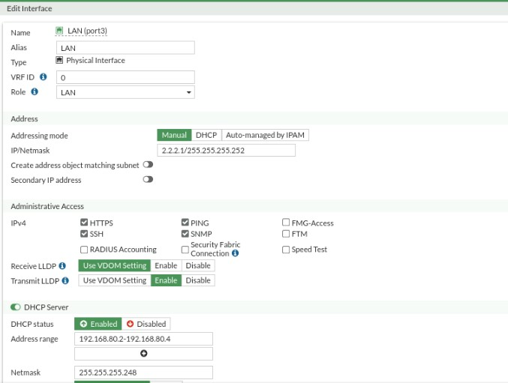

Konfigurasi WAN/Internet
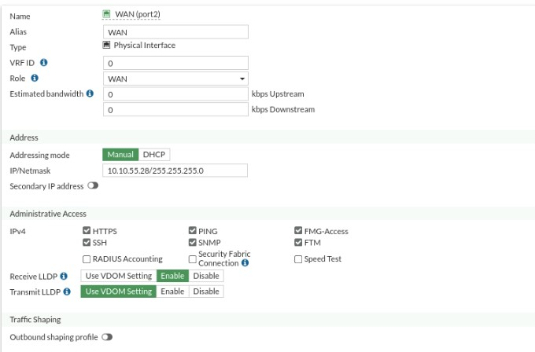

Konfigurasi IPSEC
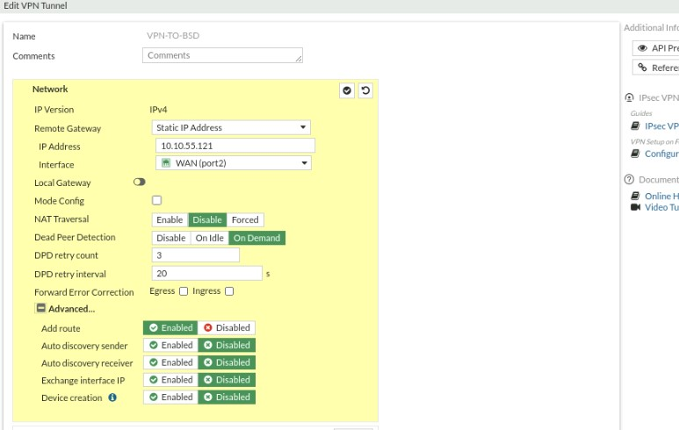
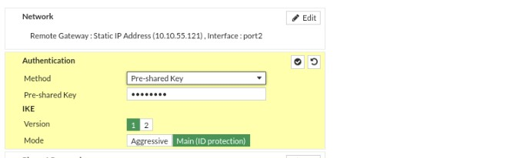
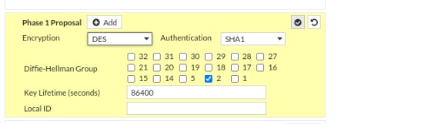

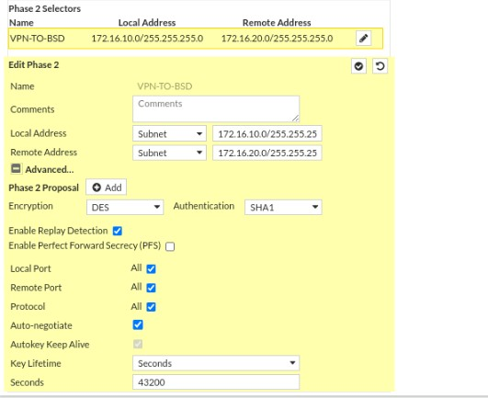

Konfigurasi Firewall Policy
Local to Internet, agar local dapat akses internet
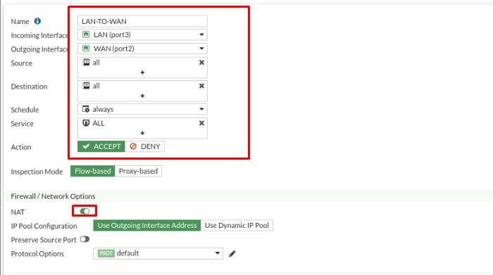

Konfigurasi local to VPN, berfungsi saat ipsec sudah jadi masing2 local dapat terhubung
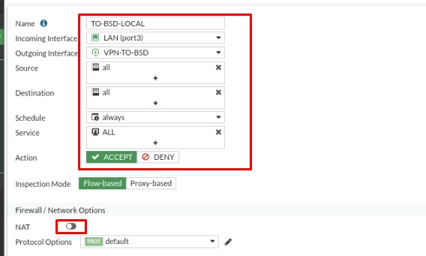

Konfigurasi Policy Mikrotik to VPN, berfungsi untuk site Bekasi dial IpSec dapat langsung diterima di Fortigate
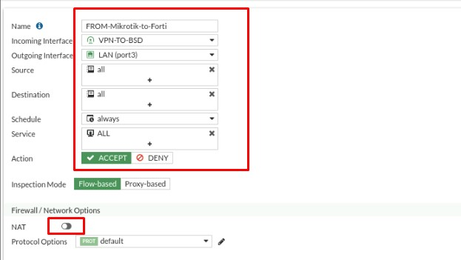

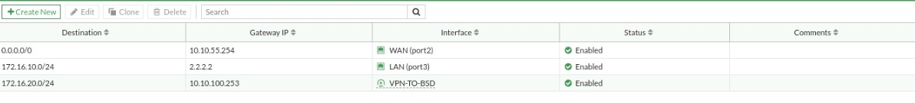
Testing jika establish makan local dari site BSD to Bekasi dapat terhubung, jika belum kalian bisa cek encrypt dari kedua Device dan juga pastikan IP Publiknya dapat terhubung. Thanks

